
RAMAIAH
Institute of Technology
USN | 1 | M | S

(Autonomous Institute, Affiliated to VTU)
(Approved by AICTE, New Delhi & Govt. of Karnataka) Accredited by NBA & NAAC with ‘A’ Grade

SEMESTER END EXAMINATIONS – JANUARY 2020

Program | : | B.E.: Information Science and Engineering | Semester | : | VII
Course Name | : | Data Mining | Max. Marks | : | 100
Course Code | : | IS71/IS721 | Duration | : | 3 Hrs

Instructions to the Candidates:
- Answer one full question from each unit.

 |  | UNIT- I
1 | a) | What is Data mining? Discuss with the neat diagram the process of knowledge discovery in Databases. | CO1 | (06)
 | b) | List the different types of Data sets? Explain any two with an example. | CO1 | (06)
 | c) | Consider the dataset shown below in Table1 to find out the frequent item sets using Apriori algorithm with the minimum support =40% and minimum confidence =60%. Generate the rules.  Table 1 | CO1 | (08)
  Tid | Items
  T1 | 1,3,4
  T2 | 2,3,5
  T3 | 1,2,3,5
  T4 | 2,5
  T5 | 1,3,5
2. | a) | Discuss three standard approaches to feature subset selection. | CO1 | (06)
 | b) | Discuss some of the specific challenges that motivated the development of data mining. | CO1 | (07)
 | c) | List the different procedures to generate Candidate item sets. Discuss any two with an example. | CO1 | (07)
 |  | UNIT- II
3. | a) | Trace the Apriori algorithm to generate frequent item-set and the rules on the following data with the minimum support 30% and minimum confidence 80%  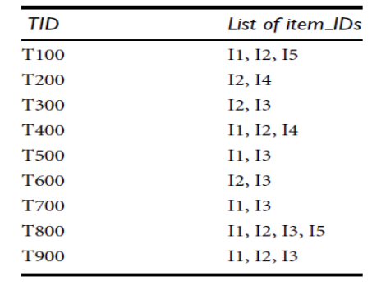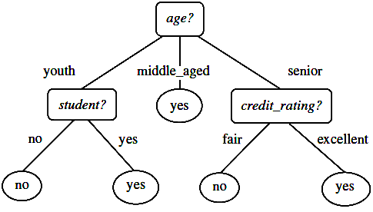 | CO2 | (10)
 | b) | Explain various kinds of Association Rule mining. | CO2 | (05)
 | c) | How are categorical and continuous attributes handled? Discuss with examples. | CO2 | (05)
4. | a) | Draw FP tree and find all frequent itemsets or frequent patterns in the following database using FP-growth algorithm. Take minimum support as 30%. | CO2 | (10)
  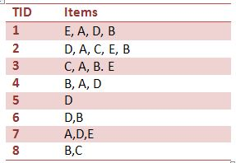
  Table 1 - Snapshot of the Database
 | b) | Compare Apriori and FP tree algorithms. | CO2 | (05)
 | c) | Explain how association patterns are evaluated. | CO2 | (05)
 |  | UNIT- III
5. | a) | Consider the training examples shown in Table 4.1 for a binary classification problem.  - Compute the Gini index for the overall collection of training examples.  - Compute the Gini index for the Customer ID attribute.  - Which attribute is better, Gender, Car Type, or Shirt Size?  Table 4.1 | CO3 | (08)
  Customer Id | Gender | Car Type | Shirt_size | Class
  1 | M | Family | S | C0
  2 | M | Sports | M | C0
  3 | M | Sports | M | C0
  4 | M | Sports | L | C0
  5 | M | Sports | XL | C0
  6 | M | Sports | XL | C0
  7 | F | Sports | S | C0
  8 | F | Sports | S | C0
  9 | F | Sports | M | C0
  10 | F | Luxury | L | C0
  11 | M | Family | L | C1
  12 | M | Family | XL | C1
  13 | M | Family | M | C1
  14 | M | Luxury | XL | C1
  15 | F | Luxury | S | C1
  16 | F | Luxury | S | C1
  17 | F | Luxury | M | C1
  18 | F | Luxury | M | C1
  19 | F | Luxury | M | C1
  20 | F | Luxury | L | C1
 | b) | Write a note on: i) rule based classifiers ii) ANN iii) naïve bayes classification approach with example. | CO3 | (12)
6. | a) | We have data from objective testing about tissue paper quality based on two attributes X1 and X2,to classify a special tissue paper whether its good or bad(table 6.1).  Now we have new paper tissue with X1=3 and X2=7 ,Classify the tissue paper using knn classification with k=3.Justify the classified value. | CO3 | (10)
  Table 6.1
  E | X2 | quality
  7 | 7 | bad
  7 | 4 | bad
  3 | 4 | good
  1 | 4 | good
 | b) | What are the causes of anomalies in the training data of the branches of the decision tree? How they may be removed using pruning approach? | CO3 | (04)
 | c) | Compare the advantages and disadvantages of eager classification versus lazy classification. | CO3 | (06)
 |  | UNIT- IV
7. | a) | Describe each of the clustering algorithms in terms of the following criteria:  - Shapes of clusters that can be determined  - Input parameters that must be specified  - Limitations  - k-means  - k-medoids  - DBSCAN. | CO4 | (07)
 | b) | For the following vectors X and Y,  X= (1,1,1,0,0,1) Y=(0,1,0,1,0,1)  Compute i) cosine similarity ii)correlation iii) Jaccard similarity. | CO1 | (06)
 | c) | Compare partitioned clustering and hierarchical clustering techniques. | CO4 | (07)
8. | a) | Consider the following eight points which has to be clustered.  A1(4, 6), A2(2, 5), A3(9, 3), A4(6, 9), A5(7, 5), A6(5, 7),A7(2, 2), A8(6, 6). Suppose initially we assign A1,A2 and A3 as the seeds of three clusters that we wish to find. Use the K-Means method to show:  - The three cluster centers after the first iteration using the Manhattan distance.  - The final three clusters | CO4 | (10)
 | b) | Briefly explain the typical requirements of clustering in data mining. | CO4 | (06)
 | c) | What is a Dendogram? Illustrate its significance in cluster analysis. | CO4 | (04)
 |  | UNIT- V
9. | a) | Explain the challenges of web data mining. | CO5 | (07)
 | b) | Explain the basic measures for text retrieval. | CO5 | (06)
 | c) | From the above table calculate the TF-IDF value of a term t4 in d2. | CO5 | (07)
  Document/term | t1 | t2 | t3 | t4 | t5 | t6 | t7
  d1 | 0 | 4 | 10 | 8 | 0 | 5 | 0
  d2 | 5 | 19 | 7 | 16 | 0 | 0 | 32
  d3 | 15 | 0 | 0 | 4 | 9 | 0 | 17
  d4 | 22 | 3 | 12 | 0 | 5 | 15 | 0
  d5 | 0 | 7 | 0 | 9 | 2 | 4 | 12
10. | a) | Discuss any four typical cases of how data analysis and data mining is used in banking and financial industry. | CO5 | (10)
 | b) | Explain the following:  - Web usage mining  - VIsion-based Page Segmentation (VIPS) | CO5 | (10)

****************

